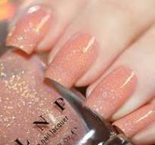

**FUTURE REQUIREMENTS**:

* Good Clients
* Location in Downtown
* Professional equipment’s and employees

**MARKETING:**

* Social media
* References of clients
* Word of mouth
* pamphlets

**LOCATION:**

Location will be set at my own place. I have a table at my room which is comfortably suits when I give service to any client

**PRODUCTS AND SERVICES:**

* Gel and acrylic nails products
* Drill machine and UV lamp
* And other common products

**Research and development:**

I try always to find that what’s my customer wants, what type of designs they like so, that I can provide services according to customer’s choice.

**BUSINESS DOCUMENTATIONS:**

Nails certificate

License for starting

Cosmetology permission

**NAIL’S BAR**

**GET YOUR NAILS DONE BY KAJAL**